**Jenkis setup for an AEM Project**

# Revision History

|  |  |  |  |
| --- | --- | --- | --- |
| **Revision No** | **Date** | **Description** | **Author** |
| 1.0 | 03/17/2014 | Initial Draft | Munuathi Dhanapal (128644) |
|  |  |  |  |
|  |  |  |  |

Table of Contents

Revision History 2

1. Introduction 4

2. Softwares required 4

3. Installation of Jenkins in Tomcat Server 4

4. Installing Jenkin’s Schedule Plugin 5

5. Configure Maven location in Jenkins 5

6. Configuring Jenkins for an AEM project maintained in SVN 6

7. Triggering a build from Jenkins 8

8. GIT configuration 9

# Introduction

The purpose of this document is to describe the step by step process of installing and configuring Jenkins for an AEM project. Jenkins provides an easy-to-use so-called continuous integration system, making it easier for developers to integrate changes to the project, and making it easier for users to obtain a fresh build. The automated, continuous build increases the productivity.

# Softwares required

* Download jenkins.war from <http://jenkins-ci.org/>
* Apache Tomcat Server
* SVN repository (where the codes are maintained for your project)
* Maven

# Installation of Jenkins in Tomcat Server

* Add Jenkins.war file into the webapp folder of tomcat

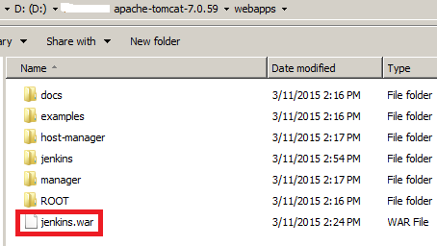

* Restart tomcat server

Note: Below log will confirm that Jenkins is running

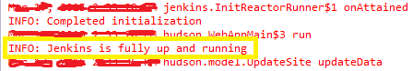

* Render Jenkins’s UI using <http://localhost:8080/jenkins/>

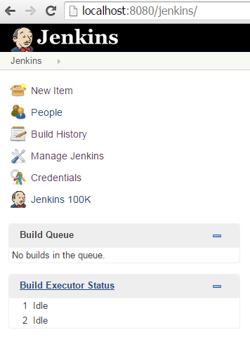

# Installing Jenkin’s Schedule Plugin

* Download plugin from <https://wiki.jenkins-ci.org/display/JENKINS/Schedule+Build+Plugin> . This will download a file named “schedule-build.hpi”
* Go to <http://localhost:8080/jenkins/pluginManager/advanced> and add the plugin using “Upload Plugin” section

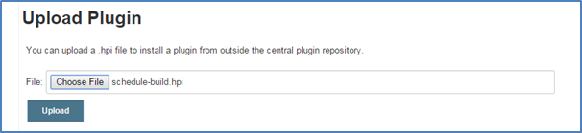

* After installing make sure the plugin is running fine using url <http://localhost:8080/jenkins/pluginManager/installed>



# Configure Maven location in Jenkins

Jenkins needs to know the location of Maven for it to execute the maven projects.

* Go to <http://localhost:8080/jenkins/configure>
* Scroll to Maven section and click on “Add Maven” button

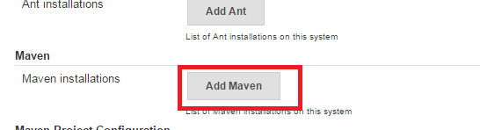

* Uncheck “Install Automatically”
* Enter “Name” and “MAVEN_HOME” and click Save

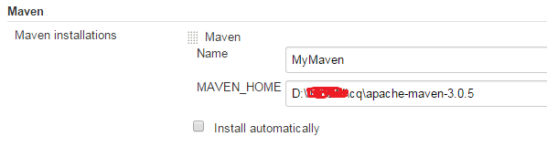

# Configuring Jenkins for an AEM project maintained in SVN

* Go to <http://localhost:8080/jenkins/>
* Click “New Item” in the left navigation

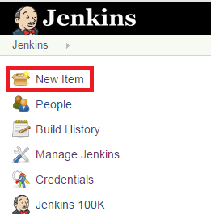

* Enter “Item name” and select “Maven Project” and click OK

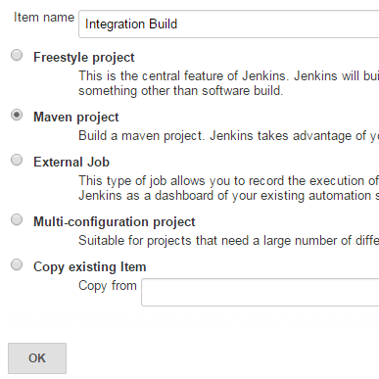

* Now start configuring your project.
* In the Configuration console of your project,
  + In “Source Code Management” section, select “Subversion” and enter your SVN repository url (For configuring GIT, check GIT Configuration)

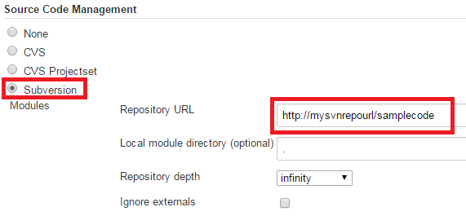

* + In “Build Triggers” section, uncheck “Build whenever a SNAPHOT dependency is built”.

Note: You can check “Build periodically”, if needed scheduled builds.

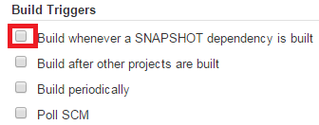

* + In “Build” section, enter the goal as “clean install”

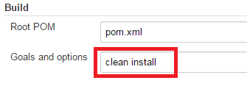

* + In “Post Steps” section, select as below:

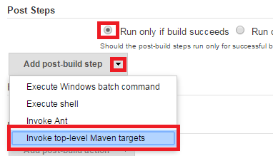

In “Invoke top-level Maven targets”, enter the special goals if your pom.xml has. For example, you can invoke profiles such as autoInstallPackage, autoInstallPackagePublish and so on

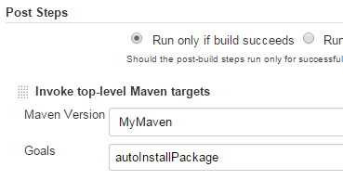

* Save all your configurations by clicking “Save” button

# Triggering a build from Jenkins

1. Go to <http://localhost:8080/jenkins/>, where you will see the list Jenkins project created
2. Click on your project
3. Click “Build Now”. This will trigger the build
4. You can monitor the build status through Console Output as below

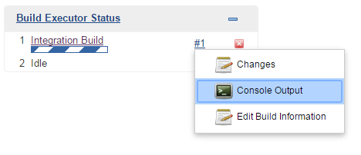

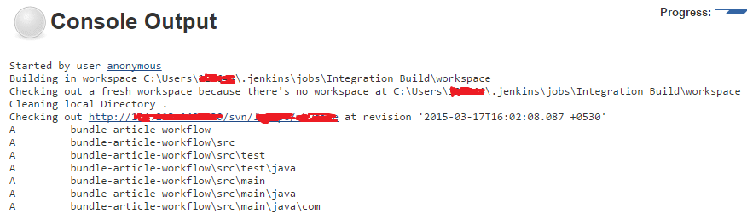

# GIT configuration

<http://localhost:8080/jenkins/pluginManager/available>

Find and select “GIT Plugin” 🡪 Click “Install without restart”

Below screen will show the successful installation of GIT plugin

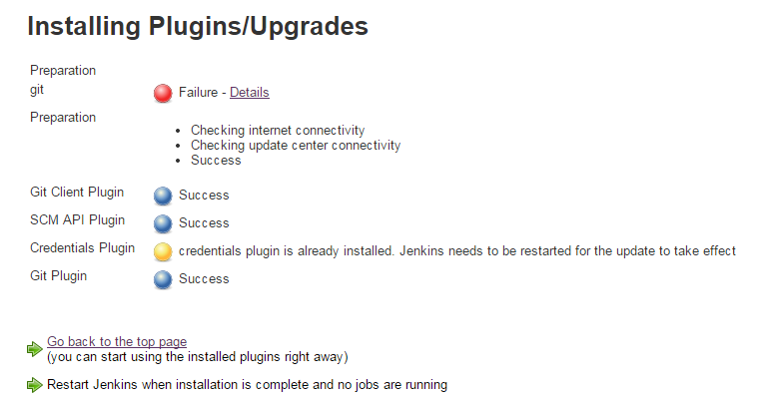

Restart “Tomcat”. Now “GIT” will start showing up under Source Code Management in the configuration console